Name and Student ID:________________________________________ Lab Section:__

Date:_________________

**Submission Instructions:**

**Prelab:**

1. **Complete the prelab**
2. **Submit this report with the prelab completed to Canvas before your lab starts**

**Lab:**

1. **Complete the lab according to the instructions**
2. **Take screenshots of your ModelSim waveform (note: to receive points your NetID has to be present in the screenshot) and insert them into this document.**
3. **Include screenshots of any related block design files or Verilog files in the report**
4. **Complete this report and reupload it to Canvas**

**PRELAB:**

**Q1.** Use Figure 1 and the table below to fill in the truth table on the next page.

|  |  |  |  |  |  |  |  |  |  |  |
| --- | --- | --- | --- | --- | --- | --- | --- | --- | --- | --- |
| X3 | X2 | X1 | X0 | Display |  | X3 | X2 | X1 | X0 | Display |
| 0 | 0 | 0 | 0 |  |  | 1 | 0 | 0 | 0 |  |
| 0 | 0 | 0 | 1 |  |  | 1 | 0 | 0 | 1 |  |
| 0 | 0 | 1 | 0 |  |  | 1 | 0 | 1 | 0 |  |
| 0 | 0 | 1 | 1 |  |  | 1 | 0 | 1 | 1 |  |
| 0 | 1 | 0 | 0 |  |  | 1 | 1 | 0 | 0 |  |
| 0 | 1 | 0 | 1 |  |  | 1 | 1 | 0 | 1 |  |
| 0 | 1 | 1 | 0 |  |  | 1 | 1 | 1 | 0 |  |
| 0 | 1 | 1 | 1 |  |  | 1 | 1 | 1 | 1 |  |

|  |  |  |  |  |  |  |  |  |  |  |
| --- | --- | --- | --- | --- | --- | --- | --- | --- | --- | --- |
| **X3** | **X2** | **X1** | **X0** | **A** | **B** | **C** | **D** | **E** | **F** | **G** |
| 0 | 0 | 0 | 0 | **0** | **0** | **0** | **0** | **0** | **0** | **1** |
| 0 | 0 | 0 | 1 |  |  |  |  |  |  |  |
| 0 | 0 | 1 | 0 |  |  |  |  |  |  |  |
| 0 | 0 | 1 | 1 |  |  |  |  |  |  |  |
| 0 | 1 | 0 | 0 |  |  |  |  |  |  |  |
| 0 | 1 | 0 | 1 |  |  |  |  |  |  |  |
| 0 | 1 | 1 | 0 |  |  |  |  |  |  |  |
| 0 | 1 | 1 | 1 |  |  |  |  |  |  |  |
| 1 | 0 | 0 | 0 |  |  |  |  |  |  |  |
| 1 | 0 | 0 | 1 |  |  |  |  |  |  |  |
| 1 | 0 | 1 | 0 |  |  |  |  |  |  |  |
| 1 | 0 | 1 | 1 |  |  |  |  |  |  |  |
| 1 | 1 | 0 | 0 |  |  |  |  |  |  |  |
| 1 | 1 | 0 | 1 |  |  |  |  |  |  |  |
| 1 | 1 | 1 | 0 |  |  |  |  |  |  |  |
| 1 | 1 | 1 | 1 |  |  |  |  |  |  |  |

**Q2.** Write the verilog code for the 7-Segment Display Decoder based on the truth table from Q1. You only need to write the skeleton code (i.e., a code which shows only a rough outline and no unnecessary or repetitive details) below.

**LAB:**

**3.0 Lab5step0**

Hardware demonstrates a good circuit.

**<<<Insert a screenshot of your Verilog file>>>**

Lab5step0 Result:

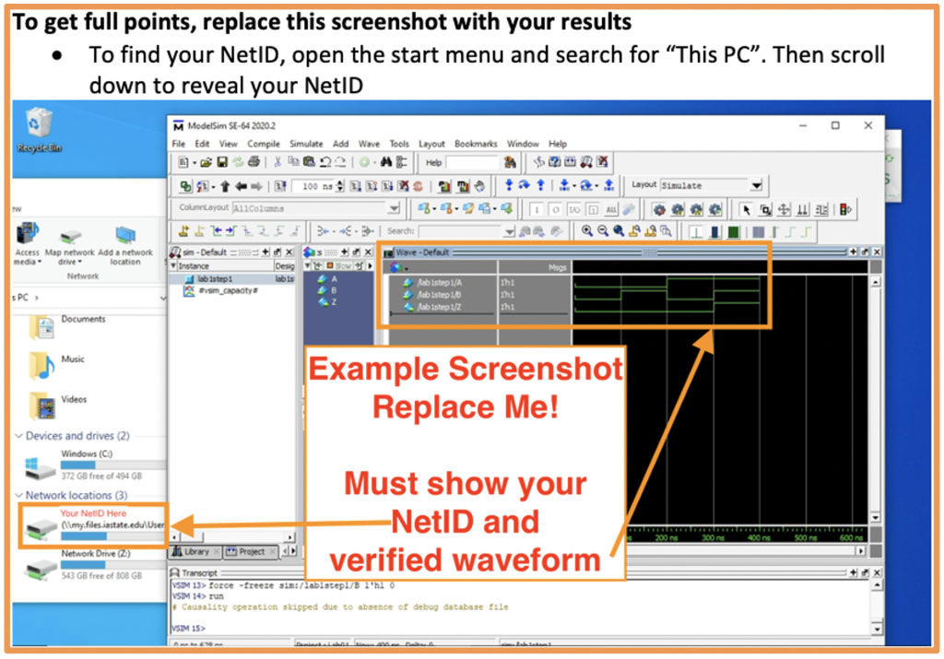

**4.0 Lab5step1**

Hardware demonstrates a good circuit.

**<<<Insert a screenshot of your BDF file here>>>**

Lab5step1 results:

